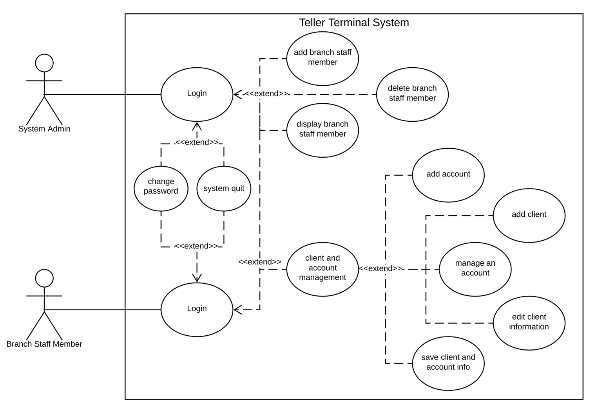

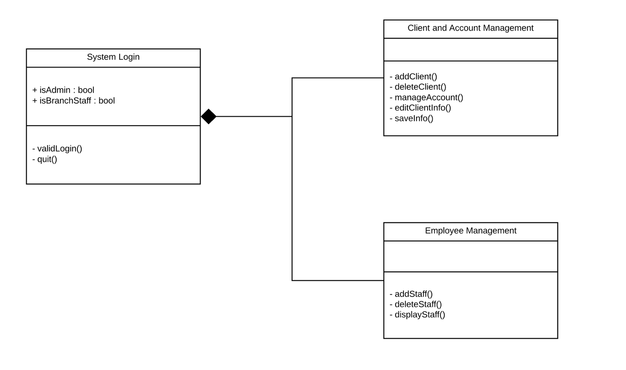

Potential Test Cases:

* Make sure system differentiates between admin and branch staff member
* Make sure adding/deleting staff member works
* Make sure adding/deleting/editing client works